Chayei Sarah. The “Conversation” in the Field
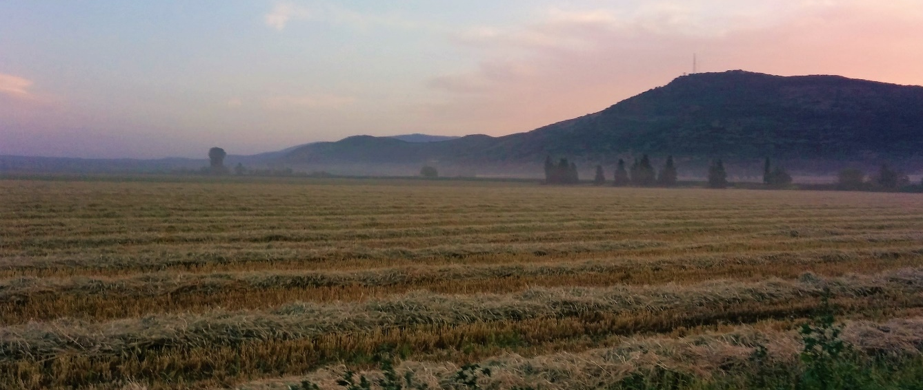
⁶³ Isaac went out to the field towards evening to converse in the field; Looking up, he saw camels approaching. ⁶⁴ Looking up, Rebekah saw Isaac. She alighted from the camel ⁶⁵and said to the servant, “Who is that man walking in the field toward us?” And the servant said, “That is my master.” So she took her veil and covered herself… ⁶⁷Isaac then brought her into the tent of his mother Sarah, and he took Rebekah as his wife. Isaac loved her, and thus found comfort after his mother’s death. (Genesis/Bereshit 24:63-67 | (סג) ויצא יצחק לשוח בשדה לפנות ערב וישא עיניו וירא והנה גמלים באים:  (סד) ותשא רבקה את עיניה ותרא את יצחק ותפל מעל הגמל:  (סה) ותאמר אל העבד מי האיש הלזה ההלך בשדה לקראתנו ויאמר העבד הוא אדני ותקח הצעיף ותתכס:  (סו) ויספר העבד ליצחק את כל הדברים אשר עשה:  (סז) ויבאה יצחק האהלה שרה אמו ויקח את רבקה ותהי לו לאשה ויאהבה וינחם יצחק אחרי אמו:  )בראשית פרק כד (

This is a touching scene. Yitzchak is in the field. He looks up and sees a caravan in the distance. At the same moment, Rivka, riding on the camel, looks up and sees a distinguished looking man in the field. It is Yitzchak, the man she is to marry. The Torah then speaks of Yitzchak’s love for Rivka, and the emotional support that she gave to Yitzchak.

But what was Yitzchak doing in the field? The Torah says that he was “conversing”. What could this mean?

The Talmud suggests say that Yitzchak was praying. He was “conversing” with God:

Isaac instituted the afternoon prayer, as it says, “Isaac went out to meditate in the field towards evening”, and ‘meditation’ means prayer, as it says, “A prayer of the afflicted … he pours out his meditation/conversation before the Lord”. (Berachot 26a)

Questions for Discussion
- Why was Isaac praying? Was it a regular thing or something specific that was on his mind?

2. The Torah says that Isaac “went out to the field towards evening “לשוח – to speak/converse/medidtate”

- Is there anything specific about that specific time – late afternoon - that might stimulate prayer?
- Is there something special about this particular location – a field - that might make it a suitable venue for Isaac to pray?
- Have you ever felt that special moment or place stimulate prayer?
- Have you ever davened on a mountaintop or in nature and felt that your prayer has more meaning? - Why do people sometimes feel that way?

3. The Talmud talks of Isaac as the founder of the afternoon prayer – Mincha – after all, he was praying “toward evening”.
- Do you daven/pray mincha?
- Is it easy to stop life midday to pray? Why should we interrupt our day to pray? Is this not a time in which I am distracted by my daily activities?

4. Or possibly, Yitzchak knew that his slave was on a mission to find a wife for him, and he was praying for a “shidduch”! Here are the words of Seforno:

"Yitzhak went to meditate in the field: He went off the path in order to 'pour out his conversation' to God. [He chose to pray specifically in] the field so that he would not be distracted by passers-by… and even before he prayed, he was answered [by Rivka's arrival.]"

Do we pray when we need something urgently? If so, why should we pray on a daily basis?

--------------------------------

Interestingly, several of our key commentators suggest that Yitzchak wasn’t in the field to pray at all!

Rashbam – To plant trees and to supervise his workers | רשב"ם  וילך יצחק לשוח בשדה - כדכת' וכל שיח השדה. כלומר לטעת אילנות ולראות עניני פועליו
Ibn Ezra – To walk amongst the plants (שיח) | אבן עזרא  (סג) לשוח ללכת בין השיחים.

According to these commentators, the word לשוח does not imply conversation, but rather a “plant” a שיח which is phonetically connected to שיחה as in “conversation”. Thus Isaac is in the field to walk amongst the foliage, or to supervise his farm; after all Isaac, unlike his father, is a farmer (see 26:12-14)

But there are two problems here. Why should the Torah mention that Isaac was taking an evening stroll, or surveying his fields? Is this an important detail? A second relates to Hebrew grammar: We find שיח as a noun, but never as a verb – לשוח. And so, Hazal, followed by Rashi, Ramban, Sephorno and others suggest that although the Torah does not specify to whom Isaac is speaking, he must be speaking or conversing; and of nobody is specified, he is probably speaking to God.

And yet this overlap between the field, plants – שיח, and prayer -שיחה , lingers.

So here are some thoughts:

The “conversation” prayer – Mincha - is specifically in the course of our work day – in the afternoon. The function of this prayer, in the middle or end of our day, is to connect our day’s activity to God and to bring the divine into the field of human activity, whether it is the material realm or that of the spirit. The essence of this prayer is not a request nor a plea, but merely to “converse.” A Human Being “pours out his conversation” before God, sharing his life with God, involving God in his interests, his worries and concerns, along with the day’s joys, and man anticipates that his prayer will find a listening ear. Like children who return at the end of the day from school or a trip, and tell their mother all the happenings of the day, both to unload emotion, but also to share experiences, and also to hear their mothers response. (Rav Yehudah Brandes) | מקומה של תפילת ה'שיחה' נקבע במהלכו של יום העבודה, בשעת המנחה. תפקידה של תפילה זו, בעיצומו או לקראת סיומו של יום, הוא לקשר את העשיה של היום אל הקדוש-ברוך-הוא ולהביא את הקדוש-ברוך-הוא לתוך שדה הפעילות של האדם. בין אם זה שדה שבחומר ובין אם שדה שברוח. עיקרה של תפילה זו אינו בתחינה ובבקשה אלא כשמה כן היא – לשוח. האדם שופך שיחו לפני ה', כביכול משתף את ה' בחייו, בקורות אותו, בטרדותיו ובשמחותיו, ומצפה שתפילתו תשמע. כמו הילד החוזר בסוף היום מבית הספר או מטיול טעון בחוויות ומספר לאמא את קורות יומו, גם כדי לפרוק מעליו, גם כדי לשתף אותה, גם כדי לקבל ממנה תגובות

A second perspective here sees nature as harmonious with prayer, or more than that – nature inspires prayer. This idea comes from the writings of Rabbi Nachman of Breslav. I will share it in the poetry of Naomi Shemer:

Know  That each and every shepherd  Has his own tune.  Know  That each and every grass  Has its own song.  And from the song of the grasses the tune of the shepherd is made  …  And from the song of the grasses,  The tune of the heart is made. | דַּע לְךָ  שֶׁכָּל רוֹעֶה וְרוֹעֶה  יֵשׁ לוֹ נִגּוּן מְיוּחָד  מִשֶׁלּוֹ  דַּע לְךָ  שֶׁכָּל עֵשֶׂב וְעֵשֶׂב  יֵשׁ לוֹ שִׁירָה מְיוּחֶדֶת  מִשֶׁלּוֹ  וּמִשִׁירַת הָעֲשָׂבִים נַעֲשֶׂה נִגּוּן  שֶׁל רוֹעֶה  ... ומשירת העשבים  נעשה ניגון  של הלב.

Why is this so?
Does nature inspire prayer?

That is a good topic to discuss at the table, while you sing this song …
https://www.youtube.com/watch?v=A-6m6CKOdC4

Shabbat Shalom!

